Mean , Median , Mode

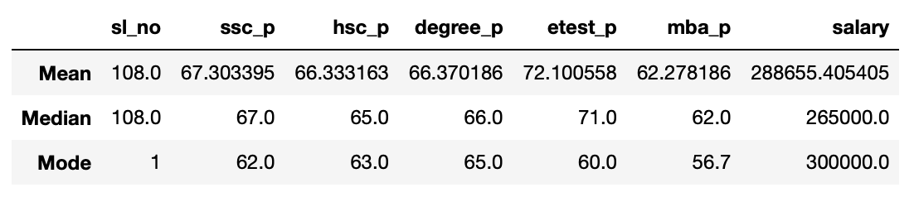

1. Mean (Average)

The mean is the average value of a set of numbers. In this table, it's the average of the values in each column.

For example, the mean of "ssc_p" is about 67.30, which means that, on average, the secondary education percentage of the people in the dataset is around 67.30.

1. Median

The median is the middle value in a set of numbers when they are arranged in order. In this table, the median of "ssc_p" is 67.0. This means that half of the people in the dataset have a secondary education percentage less than or equal to 67.0, and the other half have a percentage greater than 67.0.

1. Mode

The mode is indeed the repeated or the most frequently occurring value in a dataset. In this table, the mode of "ssc_p" is 62.0. This means that 62.0 is the most common value for secondary education percentage in the dataset.